**Guide in Using the e-RPMES**

1. **Log-in Page**
2. **Create Project**
3. **Components**
4. **RPMES Form 1**
5. **RPMES Form 2**
6. **RPMES Form 3**
7. **Account**
8. **Additional Information**

**I. LOG-IN PAGE**

1. Go to <https://erpmes-nro8.neda.gov.ph> and log-in your account.

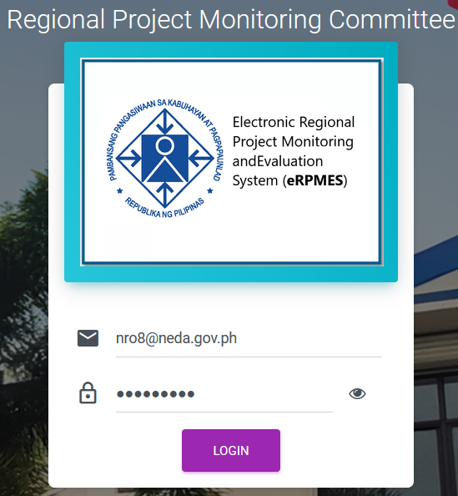

1. Three invalid attempts results to account being locked. So contact admin to unlock account.
2. Successful log in redirects to page below

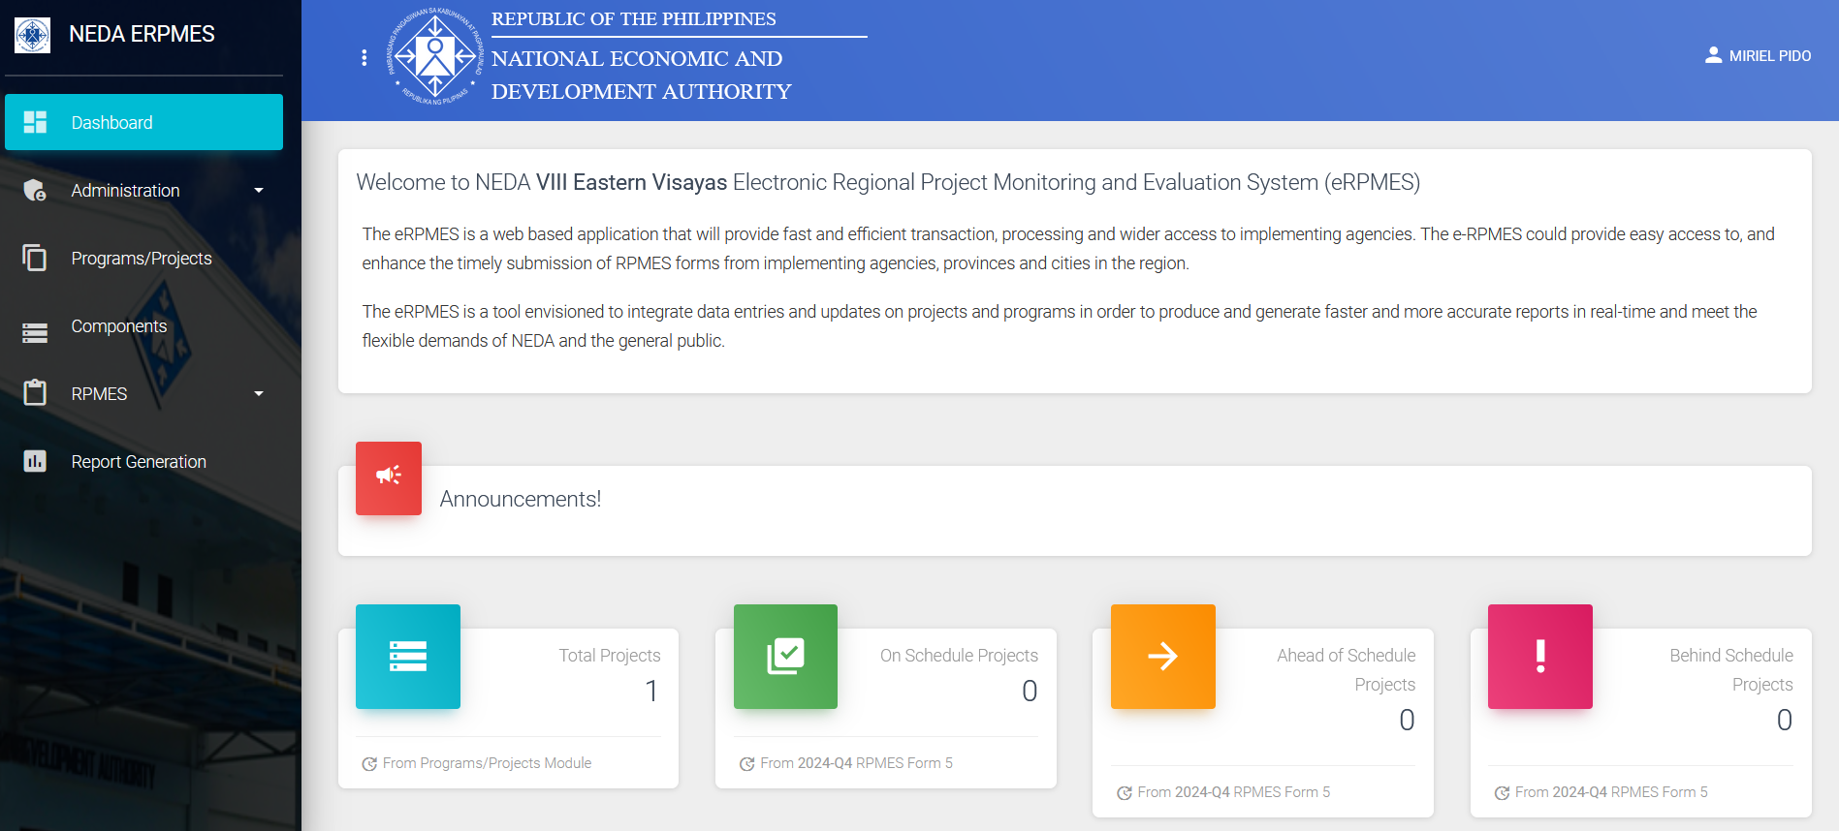

**II. CREATE PROJECT**

1. Click Programs/Projects

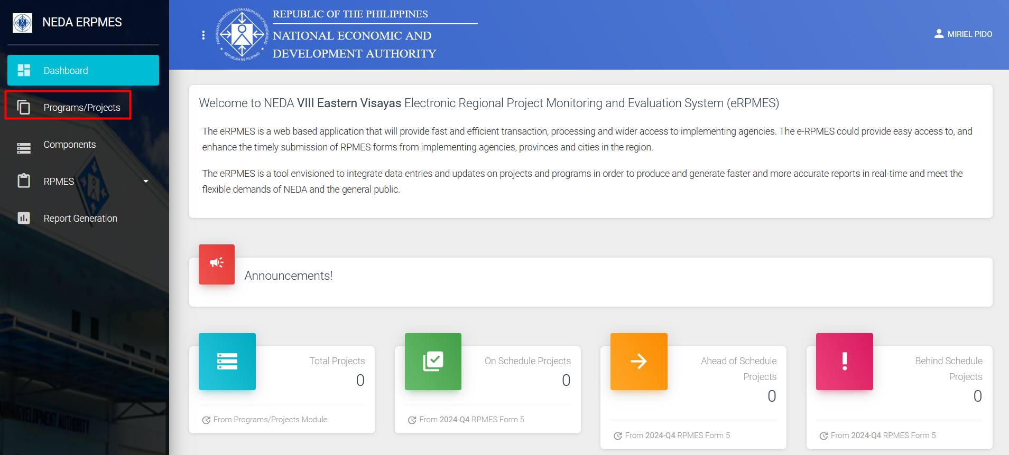

1. Click Add Project

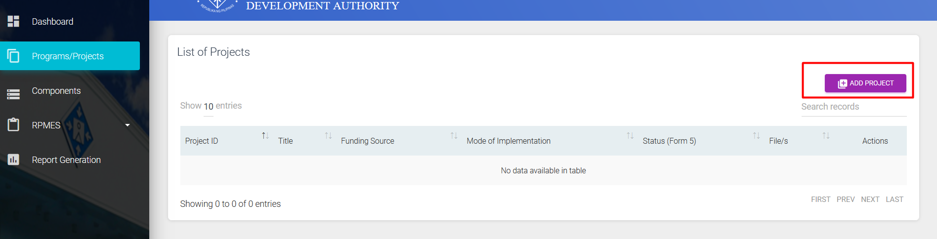

1. Fill-in details.

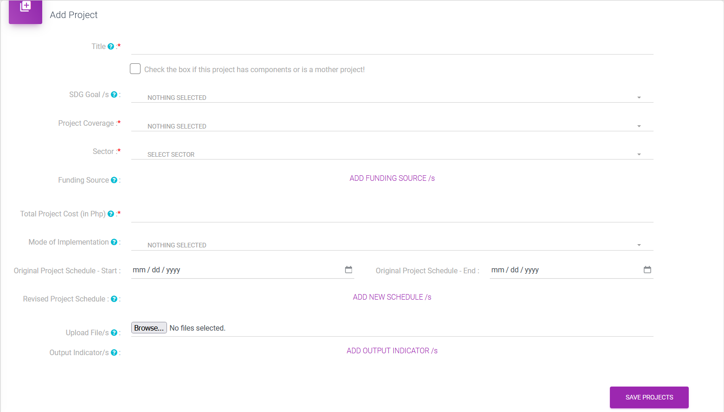

1. Check if project has component or is a mother project.

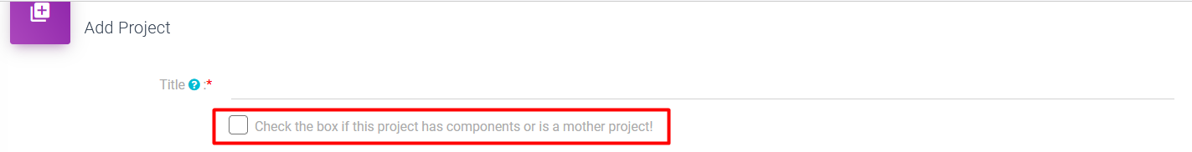

1. Click the text in Purple to add more details. Funding Source has max of 10 inputs. New Schedules has a max of 5 inputs. Output Indicators has a max of 3 inputs.

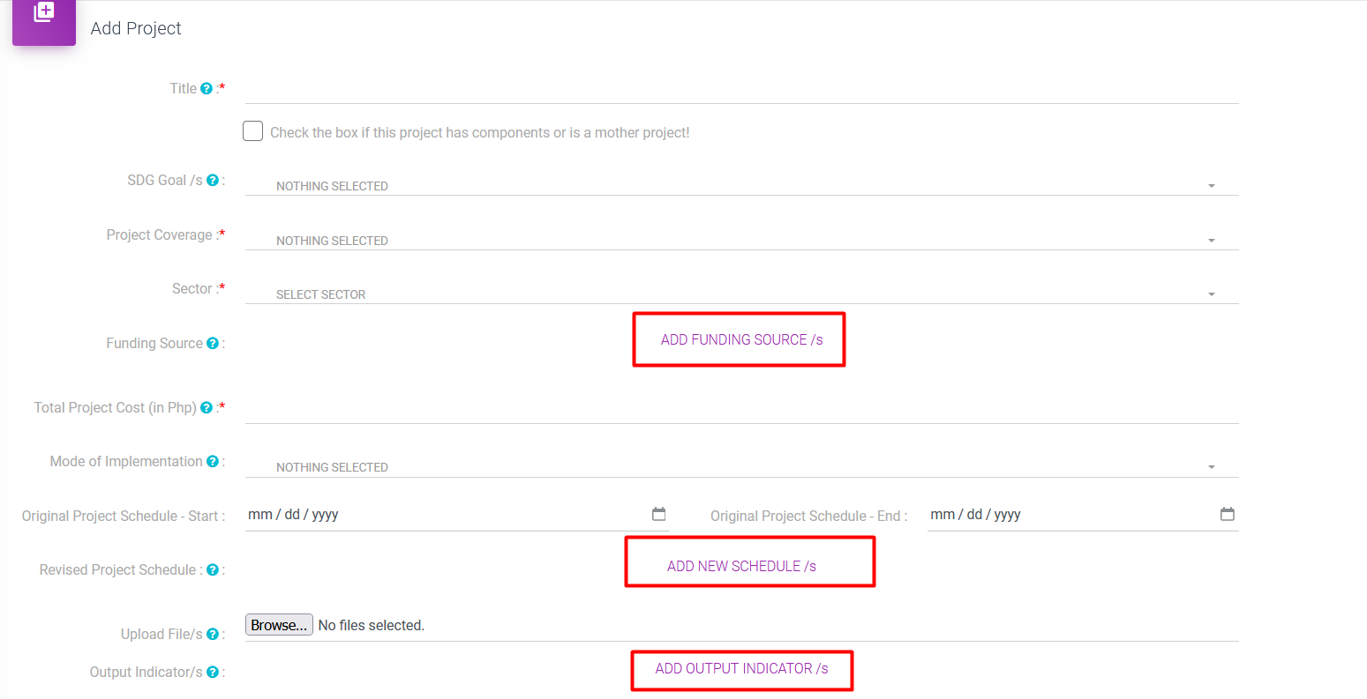

1. SDG Goals is a multiple checkbox. You can select all that applies.

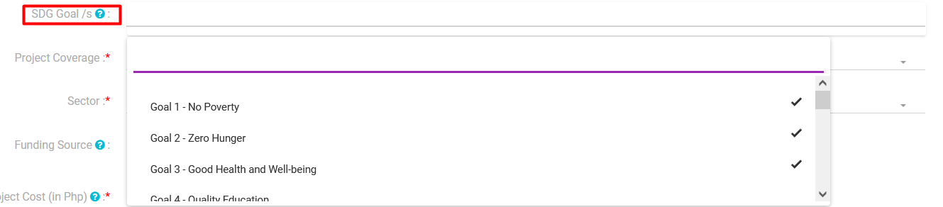

1. Province is a multiple checkbox. You can select all that applies.

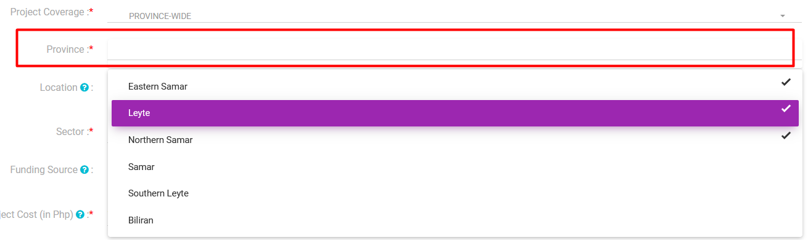

1. Click Add Location to add Location. Users can add up to 10 locations. Click on Map to add the Latitude/Longitude.

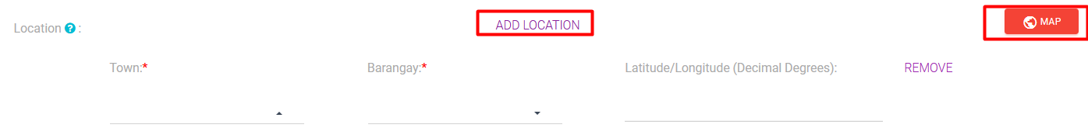

1. To input the Latitude/Longitude, click on the Map. Right click on the location and input the coordinates.

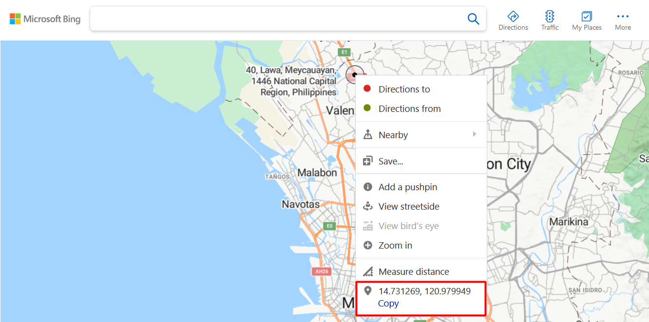

1. Upload files can upload documents and images. Maximum number of uploaded files is 10.



1. Click Save Project once done.

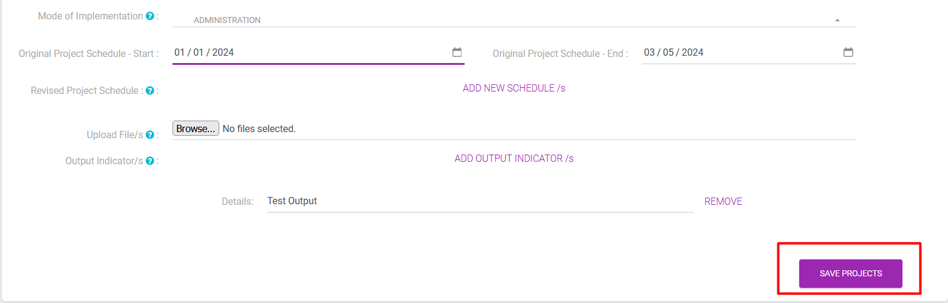

1. Saved projects can be edited anytime. No need to contact admin to edit projects.
2. Click icons on Action column to Edit or Delete Projects.

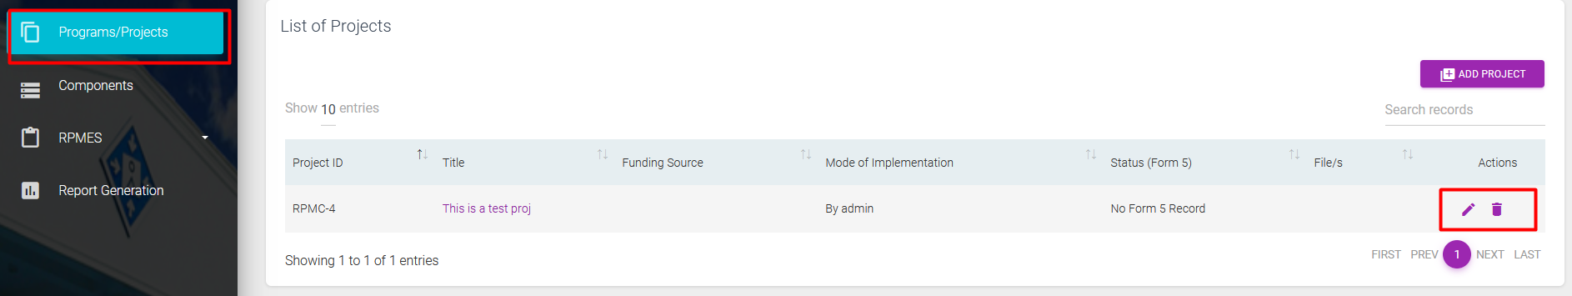

1. Multiple users of the same agency can edit their projects even if were not the ones who created the project.
2. You may add all Projects first before adding their Forms 1-4.

**III. Components**

1. For projects with components, Click on the Components and Add Component.

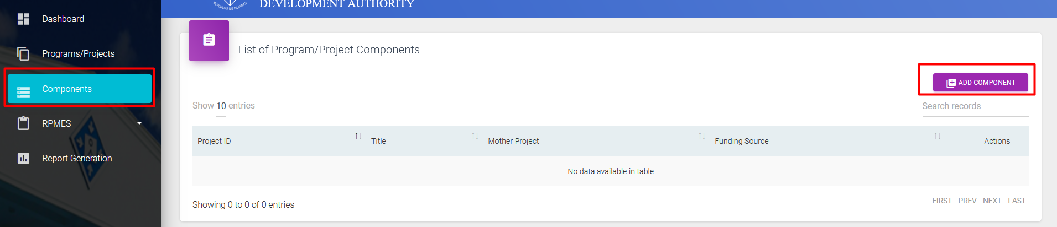

1. Fill up data and click save.

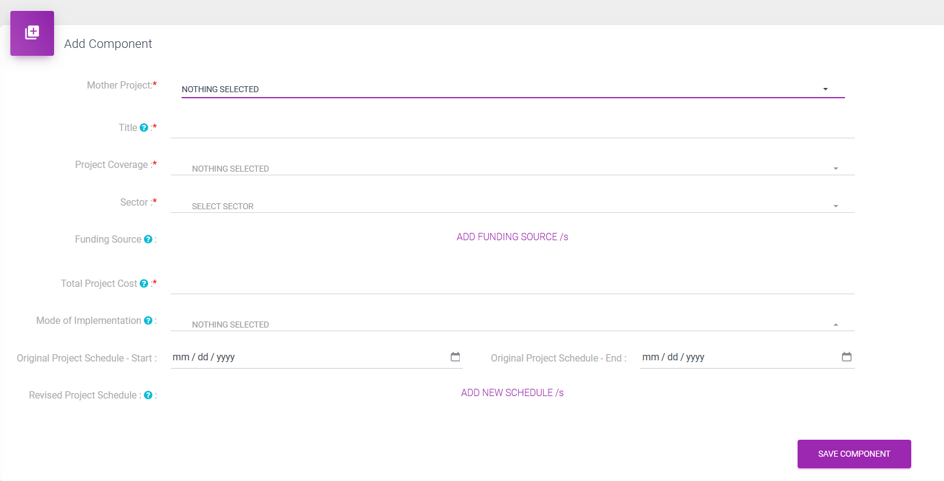

1. Saved components can be edited anytime. No need to contact admin to edit projects.
2. Click icons on Action column to Edit or Delete Components.

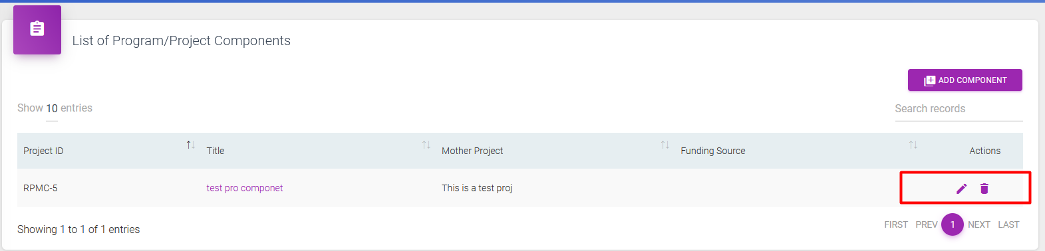

1. Multiple users of the same agency can edit their components even if were not the ones who created the components.

**IV. RPMES Form 1**

1. PMED first will give access to agencies to input on the RPMES 1.
2. Click RPMES Form 1 and + button.

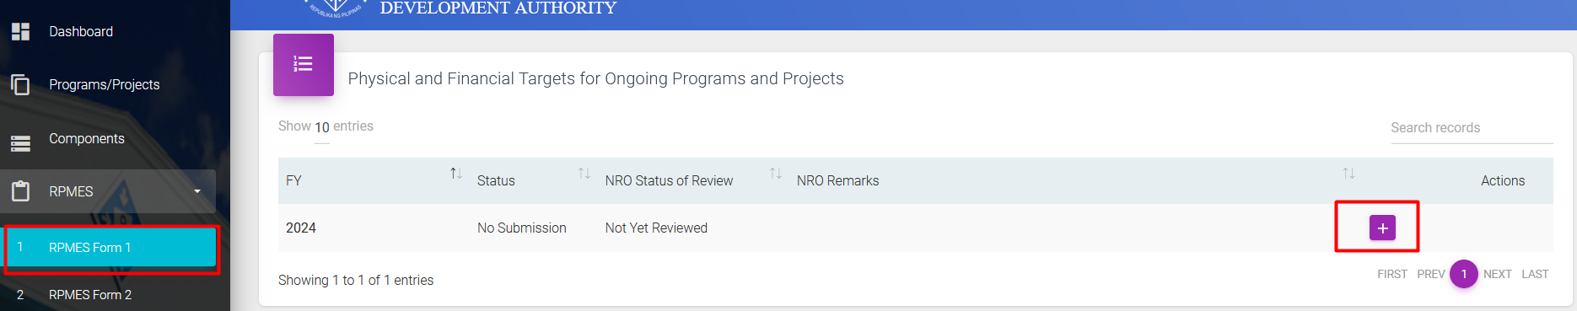

1. Click View Form 1 Projects

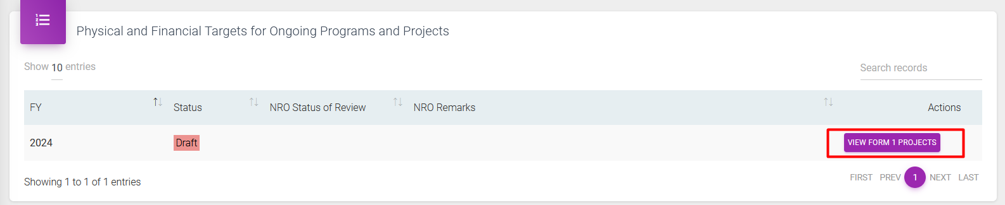

1. Click text in Purple to add data.

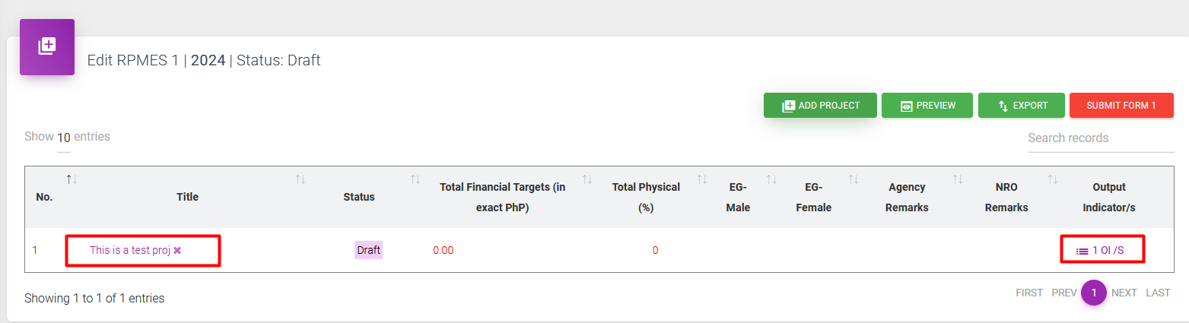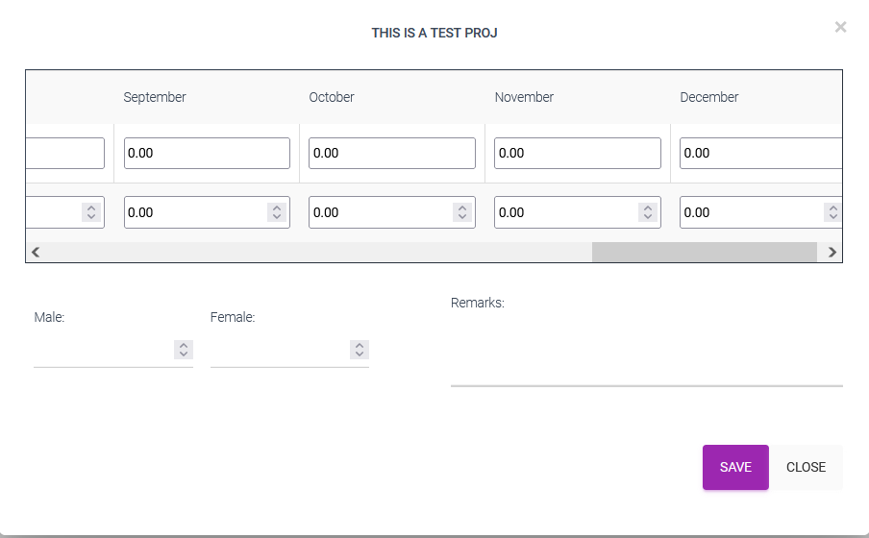

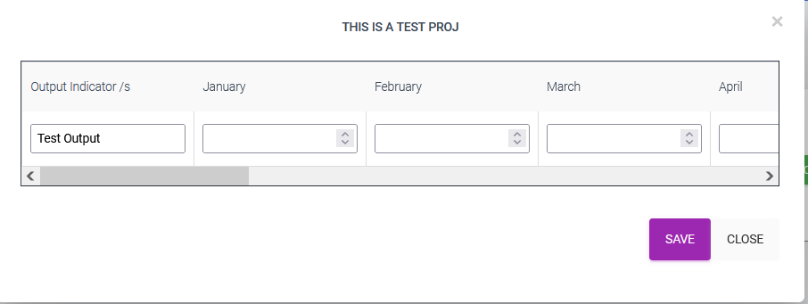

1. Note that the months are for the current year only. Any data for next year will be inputted on the next year.
2. Click Add Project if the project title is not on the list.

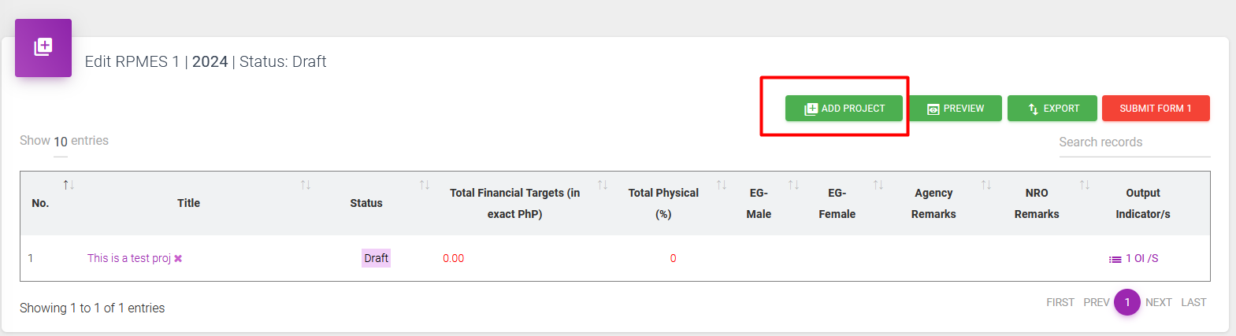

1. Use Search Bar to search for the project.

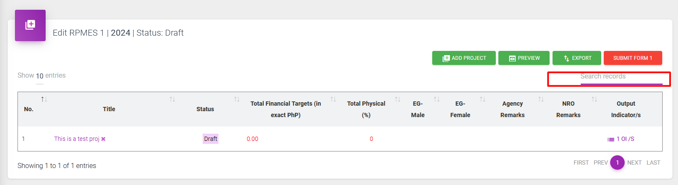

1. Click Submit Form 1 to Submit all Form 1. Note that when Submit Form 1 is not yet clicked, users may still edit all Form 1 for all projects. Once submitted and users want to change data, users need to contact Admin to change status to draft. When admin changes to draft, all Form 1 submitted within the year will be in draft form.

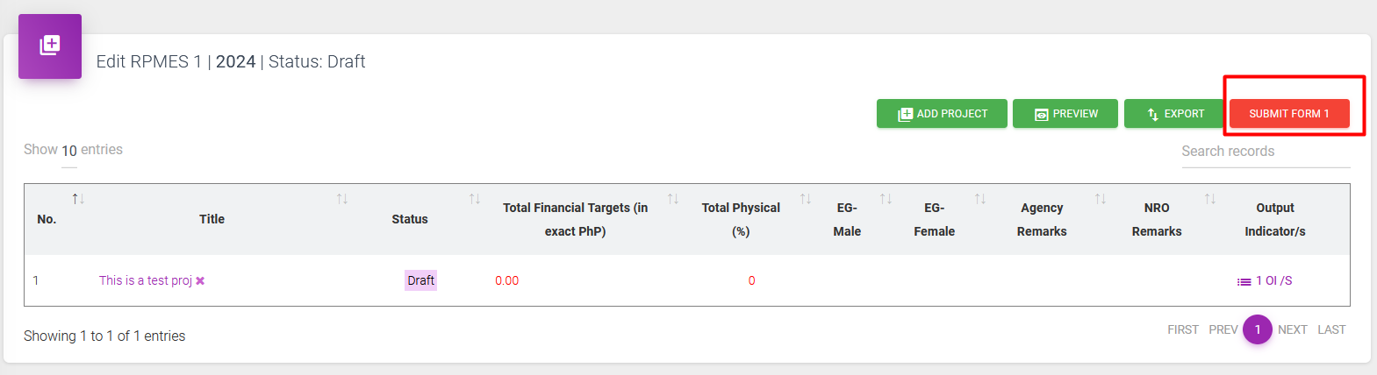

1. Submission of Form 1 is done by batch.
2. Multiple users of the same agency can edit all their Form 1.
3. Click Submit Form 1 button once done.

**V. RPMES Form 2**

1. Click on RPMES Form 2 and click on the + button for the required Quarter.

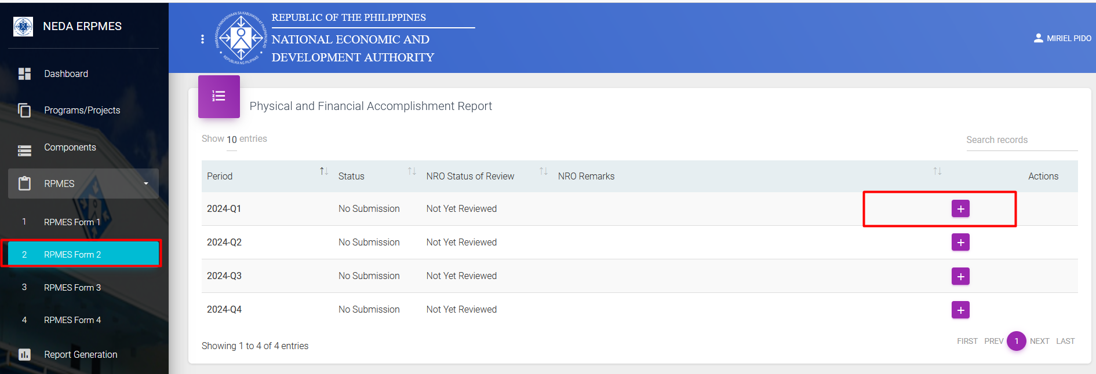

2. Click View Form 2 Projects.



3. Click text in Purple to add data.

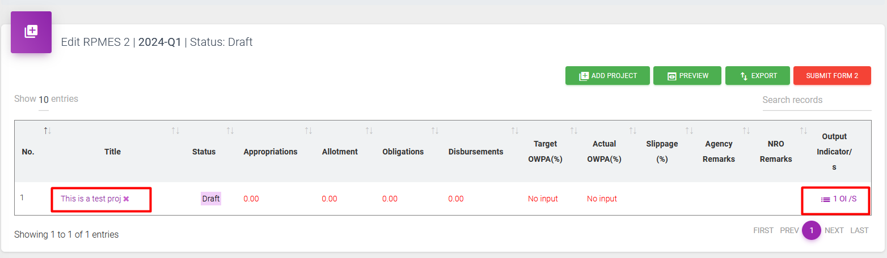

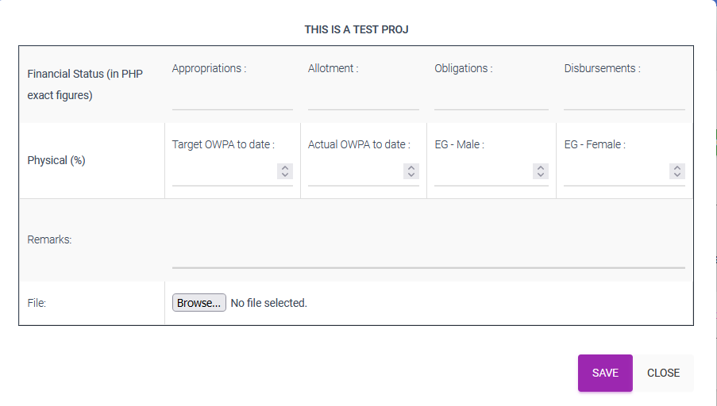

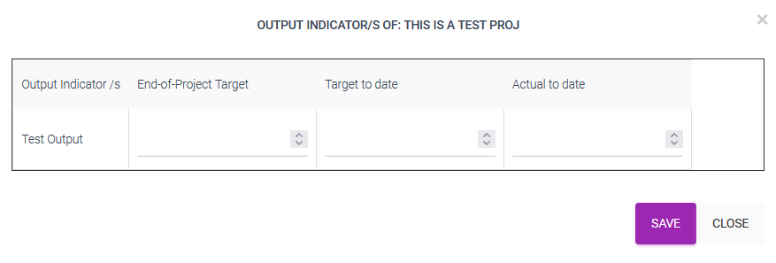

1. Click Add Project if the project title is not on the list.

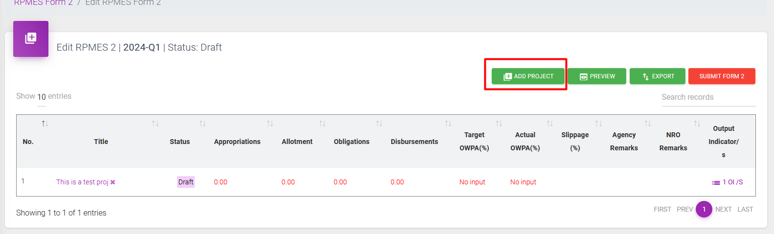

1. Use Search Bar to search for the project.

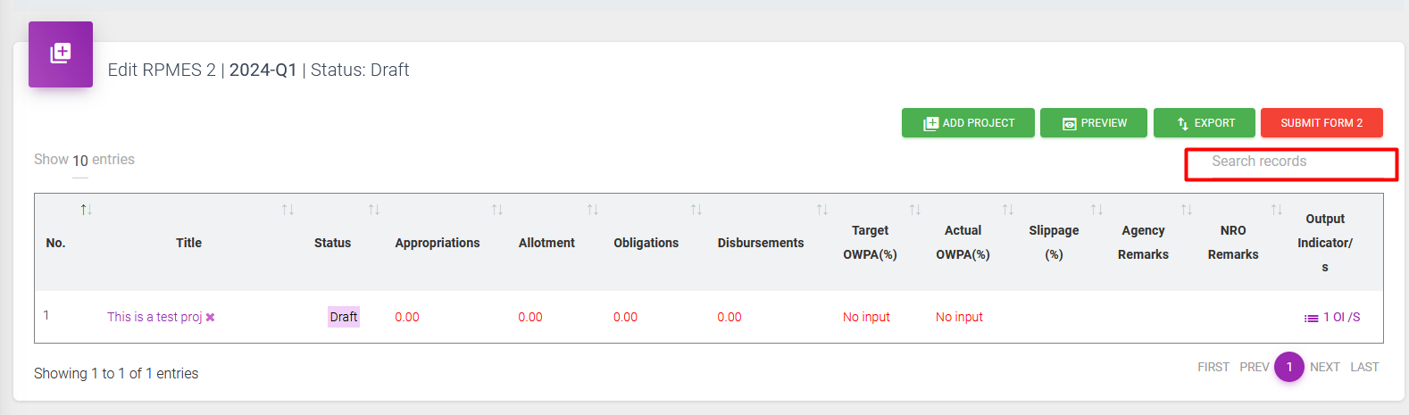

1. Click Submit Form 2 to Submit all Form 2. Note that when Submit Form 2 is not yet clicked, users may still edit all Form 2 for all projects. Once submitted and users want to change data, users need to contact Admin to change status to draft. When admin changes to draft, all Form 1 submitted within the quarter will be in draft form.

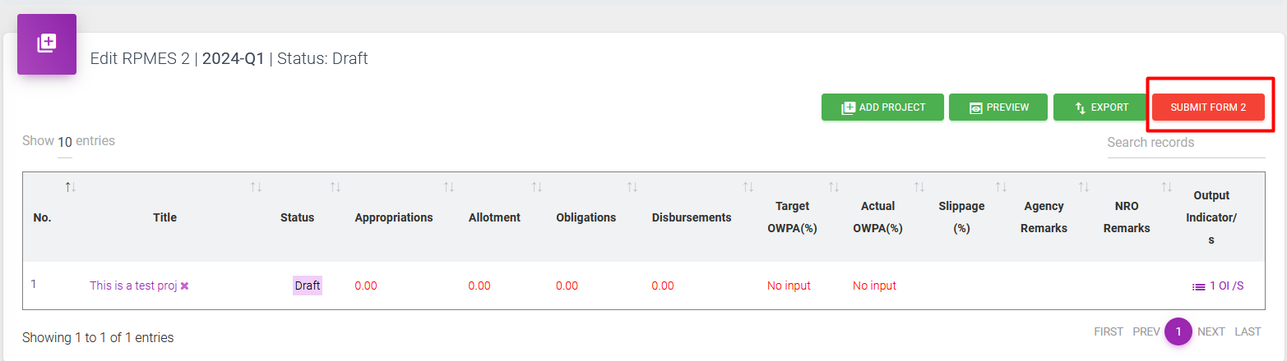

1. Submission of Form 2 is done by batch.
2. Multiple users of the same agency can edit all their Form 2.
3. Click Submit Form 2 button in order to proceed to Form 3.

**VI. RPMES Forms 3**

1. Form 2 must be submitted before users can proceed to Form 3. Click on RPMES Form 3 and click on the + button for the required Quarter.

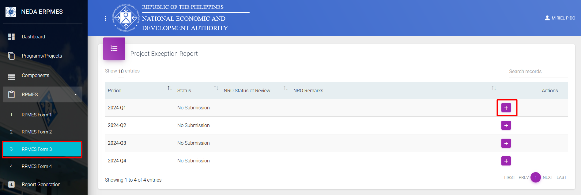

1. Data for Form 3 will only appear if there are projects with -15 % slippages from Form 2.
2. Click View Form 3 Projects button.

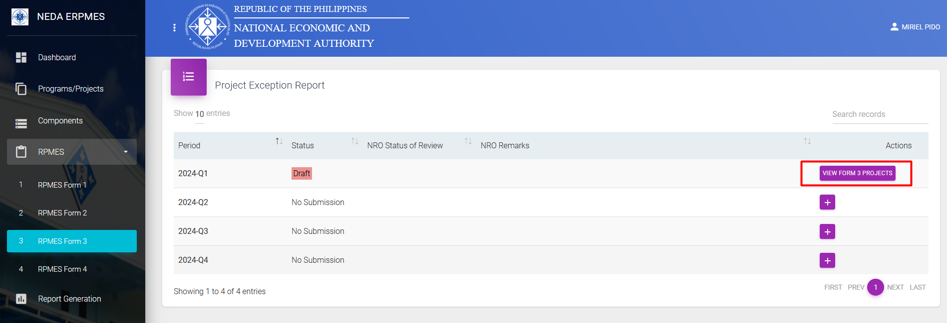

1. Click Project title to add data (text in Purple)

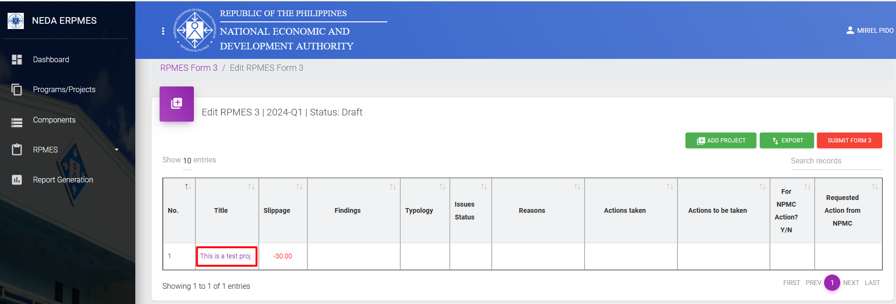

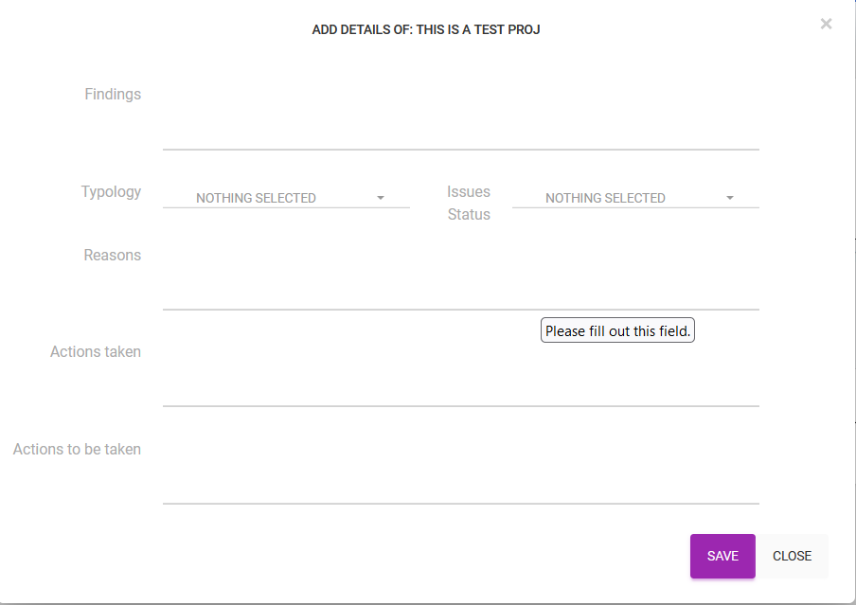

1. Click Submit Form 3 to Submit all Form3. Note that when Submit Form 3 is not yet clicked, users may still edit all Form 3 for all projects. Once submitted and users want to change data, users need to contact Admin to change status to draft. When admin changes to draft, all Form 3 submitted within the quarter will be in draft form.

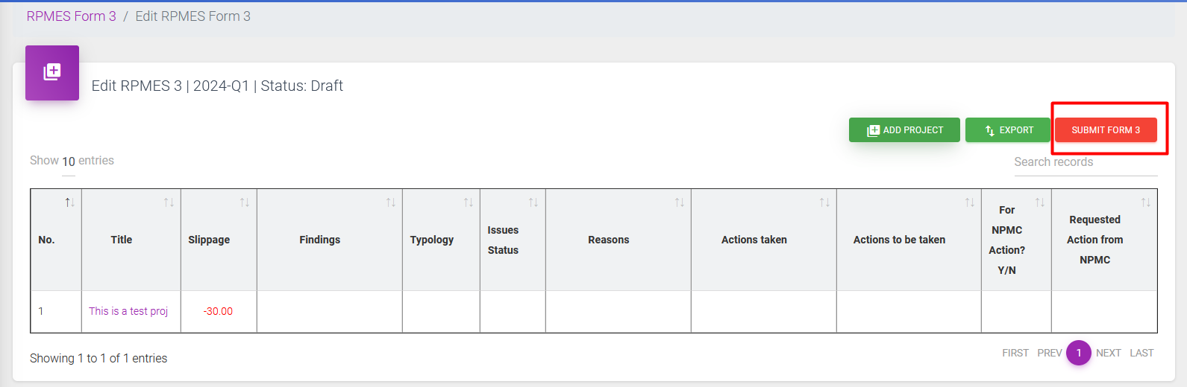

1. Submission of Form 3 is done by batch.
2. Multiple users of the same agency can edit all their Form 3.

**VII. Account**

1. Click Username and Profile to Update account details.

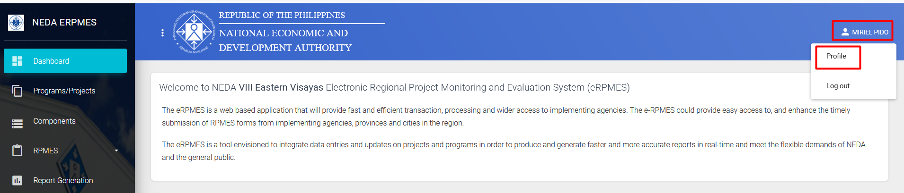

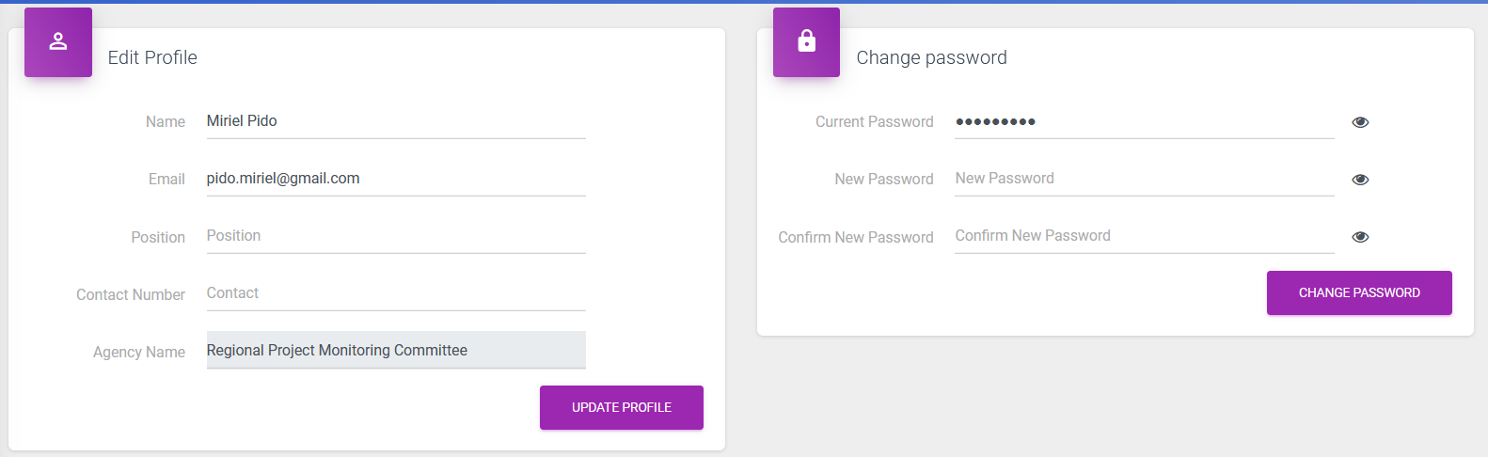

1. If user forgets the password, email Admin so Admin can change on their end.

**VIII. Additional Information**

1. On the homepage, click dashboard to view all submitted projects.

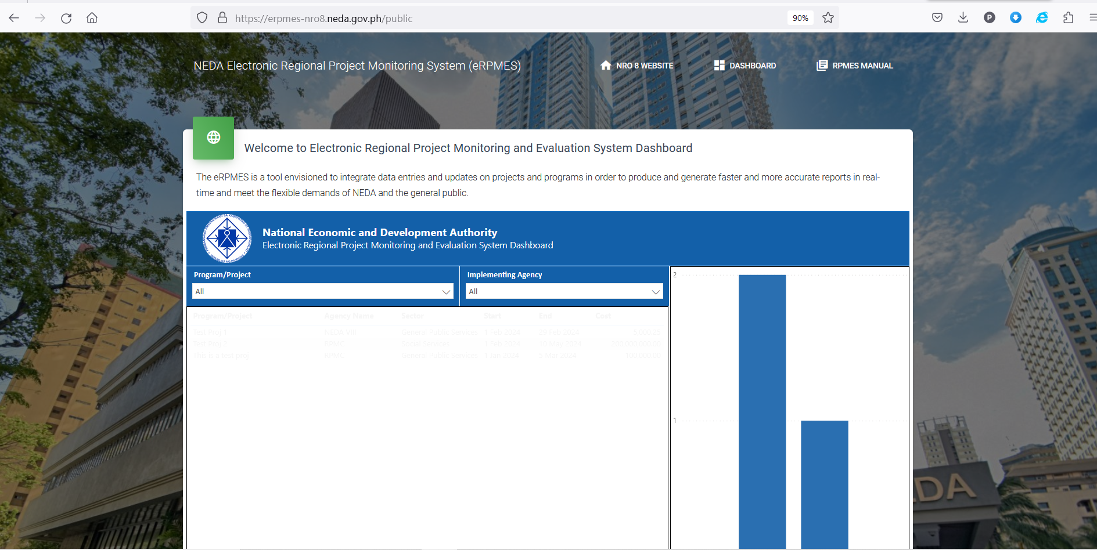

1. Forms 5 and 6 will appear once project is submitted by agencies/SUCs.
2. Agencies and admin will received emails when they submit forms.
3. Admin can comment on the forms submitted. These comments will be emailed to the agencies.
4. When forms are submitted, they are automatically published.
5. Announcements will be posted on the log the homepage.

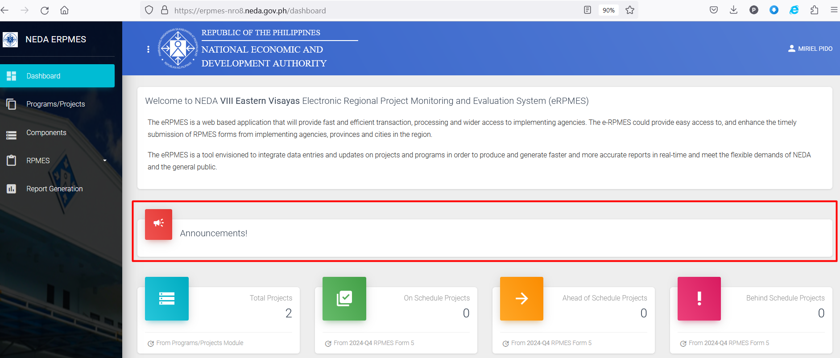

1. Agency project monitoring can also be found on the dashboard

